HTML QUICK-STYLER
Naan Mudhalvan Project Report Submitted to Manonmaniam Sundaranar University in The Partial fulfilment of the Requirement for the award of the Degree of Bachelor of Science in Information Technology.
Submitted By
Team ID: SWTID-2026-1204
Team Leader: ELAKKIYA SRI SATHYA M – 23082241808412008
Team Member: FARITHA SHAFRIN A – 23082241808412009
Team Member: FATHIMA RINOSA M – 23082241808412013
Team Member: TASNEEM FATHIMA H – 23082241808412044


DEPARTMENT OF INFORMATION TECHNOLOGY
WAVOO WAJEEHA WOMEN’S COLLEGE OF ARTS & SCIENCE
KAYALPATNAM – 628 204
APRIL – 2026

CERTIFICATE

WAVOO WAJEEHA WOMEN’S COLLEGE OF ARTS AND SCIENCE
KAYALPATNAM – 628 204
CERTIFICATE
This is to certify that project entitled as
“HTML QUICKSTYLER”
Is a Bonafide work done by
1. ELAKKIYA SRI SATHYA M – 23082241808412008
2. FARITHA SHAFRIN A – 23082241808412009
3. FATHIMA RINOSA M – 23082241808412013
4. TASNEEM FATHIMA H – 23082241808412044

In partial fulfilment of the requirement for B.Sc. Degree Course in Information Technology (2025-2026) of the Manonmaniam Sundaranar University for Naan Mudhalvan Course (Agentic AI Application Developer) is done.

Signature of the Staff Incharge

Signature of the H.O.D EXTERNAL EXAMINERS

1.

2.

DECLARATION

DECLARATION

This project is submitted for the Naan Mudhalvan Course Agentic AI Application Developer
Subject code __________ and the external examination is conducted on _____________.

Signature of the Candidates

1. ELAKKIYA SRI SATHYA M

2. FARITHA SHAFRIN A

3. FATHIMA RINOSA M

4. TASNEEM FATHIMA H

DATE:
PLACE: Kayalpatnam

CONTENT

TABLE OF CONTENT
S.NO | TOPIC | PAGE NO
1 | PROJECT DESCRIPTION | 1
2 | SCENARIOS | 3
3 | ARCHITECTURE OVERVIEW | 6
4 | PROJECT WORKFLOW | 9
5 | PROJECT STRUCTURE | 13
6 | IMPLEMENTATION PHASE | 15
7 | SCREENSHOTS | 27
8 | CONCLUSION | 31

PROJECT DESCRIPTION

1. PROJECT DESCRIPTION

HTML Quick-Styler is a smart web page creation platform that utilizes IBM’s Granite 3.3 2B Instruct model to generate complete HTML and CSS web pages with modern design and responsive layouts. The platform aims to simplify and speed up the web development process by automatically generating well-structured HTML pages, applying professional CSS styling, identifying page sections, managing color schemes, and producing ready-to-use code.
By using the advanced language capabilities of the Granite 3.3 2B model, the system interprets user inputs such as page title, required sections, and preferred colors. Based on this information, it builds a semantic HTML structure, applies contemporary CSS styles with animations, and creates responsive layouts suitable for different devices. The system also offers multiple color palette choices to improve the visual appearance of the generated pages.
HTML Quick-Styler provides a smooth and easy user experience through the Gradio interface. It combines intelligent analysis, modern design practices, accessibility considerations, and responsive design principles to deliver high-quality and personalized web pages, making web development faster and more user-friendly.

SCENARIOS

2. SCENARIOS

Scenario 1: Portfolio Website Generation
A freelance designer wants to quickly develop a professional portfolio website. The system begins by identifying the project needs and understanding the designer’s preferred style and design choices. Based on this analysis, it creates a complete website layout starting with an attractive hero section that includes a welcoming message and a clear call-to-action to capture visitor attention. Next, it generates a responsive portfolio gallery arranged in an organized grid format so that projects can be displayed neatly on all devices. An about section is also added to present the designer’s professional background and skills in an engaging way, helping visitors learn more about their expertise. To enhance reliability, the system includes a testimonials section where feedback from previous clients is displayed. A contact form with proper input validation is created to allow easy communication while minimizing errors. Finally, a well-structured footer containing social media links and important information is added to give the website a complete and professional appearance.

Scenario 2: SaaS Landing Page
A startup company requires an effective landing page to introduce and promote their new product. In response, the system designs a strong hero banner that clearly explains the product’s main value and highlights its key message. It then creates a feature showcase section where the product’s capabilities are displayed using attractive icons and short descriptions, making the benefits easy for visitors to understand. A pricing comparison table is also generated to present different plans clearly, helping users compare options and choose the most suitable one. To increase trust, the system adds a testimonials section that presents positive customer experiences and social proof. In addition, noticeable and well-placed call-to-action buttons are included throughout the page to encourage visitors to sign up or purchase the product, helping improve conversion rates.

Scenario 3: Corporate Website
A company needs a well-structured and professional corporate website with several organized sections. The system provides a clean and elegant layout that begins with a sticky navigation header containing the company logo and menu options, allowing users to move easily between different sections of the site. It then creates a company overview section that clearly explains the organization’s mission, vision, and key values. A services grid is also generated to display the company’s services with detailed descriptions in a neat and visually organized format. To make the website more engaging and trustworthy, the system adds a team members section that includes photographs and short introductions of staff members. A contact section is also included with company details and an inquiry form to enable smooth communication with visitors. Finally, the website is completed with a professional footer that contains privacy policies and important links, ensuring a polished and corporate-level presentation.

Scenario 4: Custom Color Palette Exploration
A designer wants to test various color combinations to discover the most suitable visual identity for their project. The system generates eight carefully designed color palettes, including themes such as modern, vibrant, ocean, forest, sunset, luxury, creative, and minimal styles. Each palette provides clearly defined hex color codes for all design elements, making it easy to apply them during development. The system also offers a real-time preview feature that allows the designer to instantly see how each color scheme influences the overall look of the website. It maintains consistent color usage across all components to ensure a balanced and harmonious design. In addition, the system includes dark theme–optimized backgrounds that align with current design trends and enhance the user experience, especially in low-light viewing conditions.

ARCHITECTURE OVERVIEW

3. ARCHITECTURE OVERVIEW

HTML Quick-Styler is designed as a modular system that integrates a Python-based backend with the IBM Granite 3.3 2B Instruct model to enable intelligent HTML page generation. The architecture focuses on delivering a smooth user experience, high-quality design output, and efficient code generation through Gradio’s interactive interface along with advanced template creation techniques.

Core Technologies
• Python 3.x: Main programming language used to implement the system logic and backend functionality.
• IBM Granite 3.3 2B Instruct: AI model responsible for generating intelligent and structured HTML content.
• Gradio: Web interface framework that allows users to interact with the system easily.
• HTML5/CSS3: Standard web technologies used for building modern and responsive web pages.
• JavaScript: Enables client-side functionality, animations, and dynamic behavior.
• Google Colab: Cloud-based platform used for development and execution of the application.
• Responsive Design: Uses a mobile-first approach with media queries to ensure compatibility across devices.
Pre-requisites

Software Requirements
• Python 3.8+: Available for download from python.org.
• Google Account: Needed to access and run the project in Google Colab.
• Gradio: Can be installed using pip (pip install gradio).
• Web Browser: Modern browsers such as Chrome, Firefox, Safari, or Edge.
• Internet Connection: Necessary for accessing Google Colab and the AI model.

Knowledge Prerequisites

• Basic Python Knowledge: Understanding of functions, classes, dictionaries, and string handling.
• HTML/CSS Basics: Familiarity with webpage structure and styling concepts
• Gradio Framework: Basic knowledge of creating interface components.
• Web Design: Awareness of color theory and responsive design concepts.
• Google Colab: Basic understanding of working with notebook environments.

Hardware Requirements

• Processor: Intel i3 or similar processor (most processing runs on Colab’s cloud servers).
• RAM: Minimum of 4GB on the local system.
• Storage: At least 1GB of free space for storing generated files.
• Display: Screen resolution of at least 1280 × 720 for proper interface viewing.

PROJECT WORKFLOW

4. PROJECT WORKFLOW

Phase 1: Environment Setup & Model Configuration

Prepare the Google Colab environment and configure the Granite AI model.

Activity 1.1: Set up Google Colab Environment
• Create a new notebook in Google Colab.
• Enable GPU runtime to improve performance.
• Install all the necessary Python libraries.
• Verify environment configuration.

Activity 1.2: Configure IBM Granite Model
• Access the model from the Hugging Face repository.
• Load the Granite 3.3 2B Instruct model into the environment.
• Perform initial tests to verify model inference.
• Adjust and set appropriate generation parameters.

Activity 1.3: Install and Configure Gradio
• Install Gradio via pip
• Run a basic Gradio interface to test functionality.
• Configure sharing and accessibility options.
• Ensure that the interface renders correctly in the browser.

Phase 2: Core Application Development

Develop the main HTML generation engine and template framework.
Activity 2.1: Creating the Color Palette Generator
- Design the ColorPaletteGenerator class.
- Define eight different color palette styles.
- Implement logic for selecting palettes.
- Add a method for validating color values.

Activity 2.2: Implement HTML Page Builder
• Develop the HTMLPageBuilder class.
• Create an algorithm for detecting required page sections.
• Implement template generation methods
• Build a generator for SEO-friendly meta tags.

Activity 2.3: Developing the CSS Generation Engine
- Design a full CSS generation system.
- Implement rules for responsive layouts.
- Add animation and transition effects for better visual experience.
- Include mobile-first media queries for device compatibility.
Activity 2.4: Creating Section Templates
- Design a hero section template.
- Develop a features grid layout.
- Implement a portfolio gallery template.
- Add a contact form template.
- Create pricing table and testimonial section templates.

Phase 3: Gradio Interface Development

Design a user-friendly interactive interface with multiple tabs.

Activity 3.1: Interactive HTML Generation & Preview Interface
In this phase, a complete interface is designed to allow users to generate, customize, preview, and explore web page layouts. The system provides an intuitive workflow where users can easily interact with different sections, visualize outputs, and understand the generated page structure.
Phase 4: Google Colab Deployment:
Integrate all modules and conduct full system testing.
Activity 4.1: End-to-End Integration
- Connect all interface components together.
- Test the data flow between different tabs.
- Verify the HTML generation pipeline.
- Check error handling and system stability.

Phase 5: Deployment & Documentation

Deploy the application and prepare detailed documentation.
Activity 5.1: Functionality Testing
- Configure Gradio sharing options.
- Generate a public access link for the application.
- Test accessibility from external systems.
- Document the deployment procedure and usage instructions.

TECHNICAL STRUCTURE
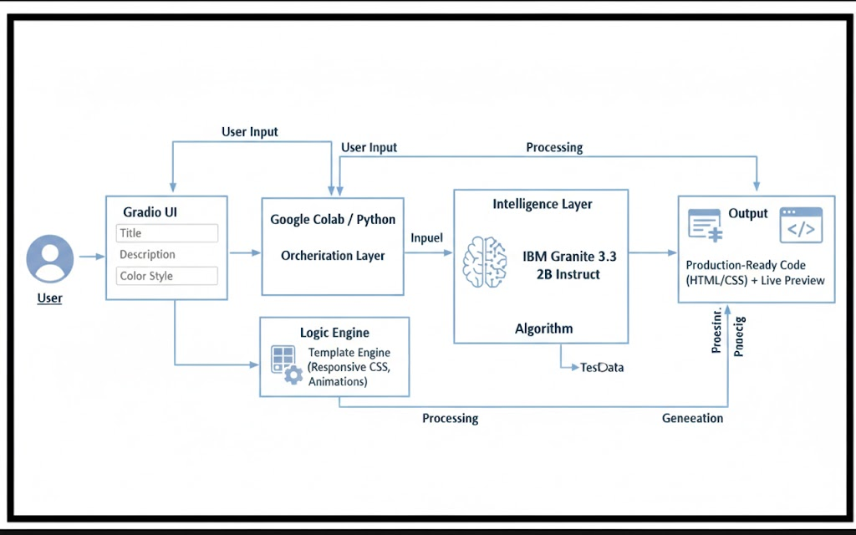

PROJECT STRUCTURE

5.PROJECT STRUCTURE

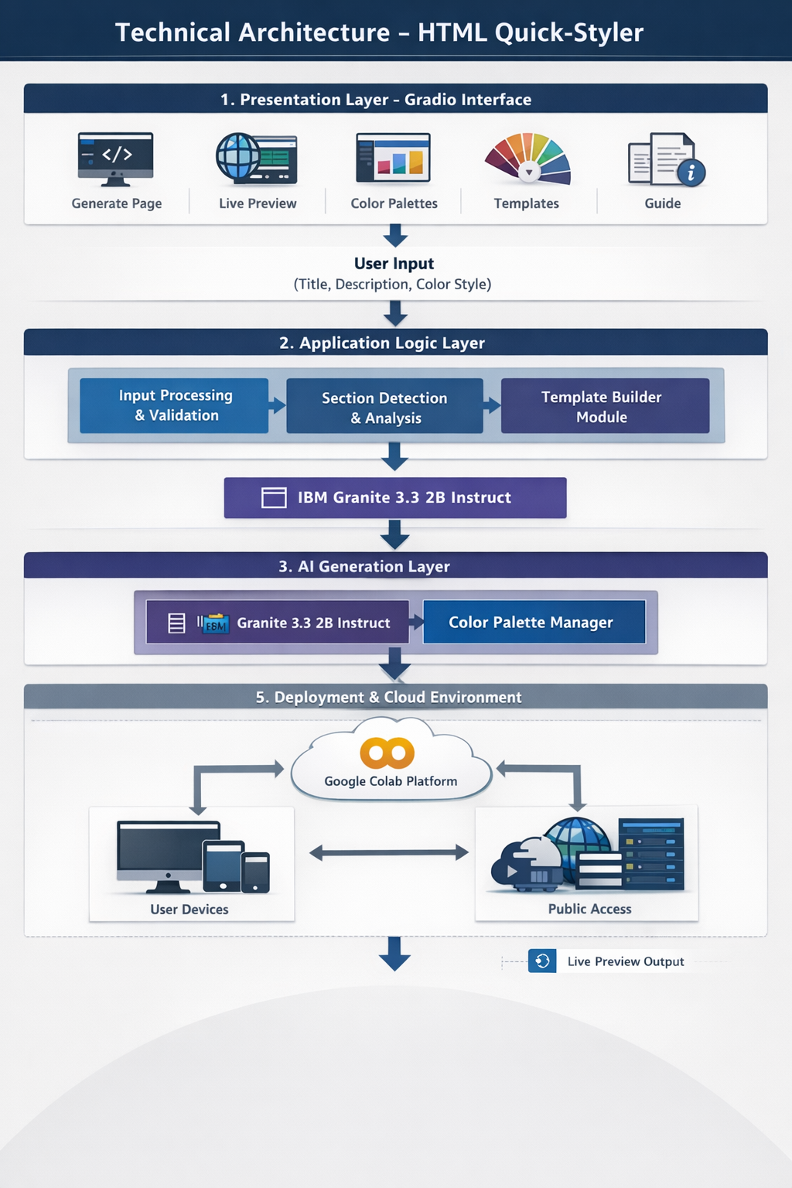

IMPLEMENTATION PHASE

6. IMPLEMENTATION PHASE

Activity 1.1:Install Dependencies & Setup Environment
!pip install -q gradio
import gradio as gr
import json
import re
from datetime import datetime
from typing import Tuple, Dict, List
import random

Activity 2.1: Color Palette Generator Implementation
class ColorPaletteGenerator:
"""Generate visually cohesive color palettes"""
@staticmethod
def generate_palette(style: str = "modern") -> Dict[str, str]:
"""Generate a cohesive color palette based on style"""
palettes = {
'modern': {
'primary': '#667eea',
'secondary': '#764ba2',
'accent': '#f093fb',
'background': '#0f172a',
'surface': '#1e293b',
'text_primary': '#f1f5f9',
'text_secondary': '#cbd5e1',
'border': '#334155'
},
'vibrant': {
'primary': '#ff6b6b',
'secondary': '#ff8e72',
'accent': '#f5576c',
'background': '#0f172a',
'surface': '#1e293b',
'text_primary': '#f1f5f9',
'text_secondary': '#cbd5e1',
'border': '#334155'
},
'ocean': {
'primary': '#0099cc',
'secondary': '#006699',
'accent': '#00ccff',
'background': '#0f172a',
'surface': '#1e293b',
'text_primary': '#f1f5f9',
'text_secondary': '#cbd5e1',
'border': '#334155'
},
'forest': {
'primary': '#27ae60',
'secondary': '#1e8449',
'accent': '#52be80',
'background': '#0f172a',
'surface': '#1e293b',
'text_primary': '#f1f5f9',
'text_secondary': '#cbd5e1',
'border': '#334155'
},
'sunset': {
'primary': '#ff8c42',
'secondary': '#ff6b35',
'accent': '#ffa751',
'background': '#0f172a',
'surface': '#1e293b',
'text_primary': '#f1f5f9',
'text_secondary': '#cbd5e1',
'border': '#334155'
},
'luxury': {
'primary': '#1a1a1a',
'secondary': '#333333',
'accent': '#FFD700',
'background': '#0f172a',
'surface': '#1e293b',
'text_primary': '#f1f5f9',
'text_secondary': '#cbd5e1',
'border': '#334155'
},
'creative': {
'primary': '#9b59b6',
'secondary': '#8e44ad',
'accent': '#e74c3c',
'background': '#0f172a',
'surface': '#1e293b',
'text_primary': '#f1f5f9',
'text_secondary': '#cbd5e1',
'border': '#334155'
},
'minimal': {
'primary': '#2c3e50',
'secondary': '#34495e',
'accent': '#3498db',
'background': '#0f172a',
'surface': '#1e293b',
'text_primary': '#f1f5f9',
'text_secondary': '#cbd5e1',
'border': '#334155'
}
}

Activity 2.2: HTML Page Builder Implementation
class HTMLPageBuilder:
"""Build styled HTML pages from descriptions"""
@staticmethod
def extract_sections(description: str) -> List[str]:
"""Extract sections from description"""
sections = []
section_keywords = {
'hero': ['hero', 'banner', 'landing'],
'features': ['features', 'services', 'benefits'],
'about': ['about', 'team', 'company'],
'portfolio': ['portfolio', 'gallery', 'work', 'projects'],
'testimonials': ['testimonial', 'reviews', 'feedback'],
'pricing': ['pricing', 'plans', 'cost'],
'contact': ['contact', 'form', 'reach'],
'footer': ['footer', 'bottom']
}
desc_lower = description.lower()
for section_type, keywords in section_keywords.items():
for keyword in keywords:
if keyword in desc_lower:
sections.append(section_type)
break
if not sections:
sections = ['hero', 'features', 'contact', 'footer']
return sections
@staticmethod
def generate_meta_tags(title: str, description: str) -> str:
"""Generate SEO meta tags"""
meta_tags = f''' <meta charset="UTF-8">
<meta name="viewport" content="width=device-width, initial-scale=1.0">
<title>{title}</title>
<meta name="description" content="{description[:160]}">
<meta name="theme-color" content="#0f172a">
<meta property="og:title" content="{title}">
<meta property="og:description" content="{description[:160]}">
<meta property="og:type" content="website">
<meta name="twitter:card" content="summary_large_image">
<meta name="author" content="HTML Quick-Styler">'''
return meta_tags
@staticmethod
def generate_section_html(section_type: str, palette: Dict) -> str:
"""Generate HTML for specific section"""
sections = {
'hero': f''' <section class="hero">
<div class="hero-content">
<h1>Welcome to Your Site</h1>
<p>Create amazing web experiences</p>
<button class="btn btn-primary">Get Started</button>
</div>
</section>''',
'features': f''' <section class="features">
<h2>Features</h2>
<div class="features-grid">
<div class="feature-card">
<h3>Fast</h3>
<p>Lightning-quick performance</p>
</div>
<div class="feature-card">
<h3>Secure</h3>
<p>Enterprise-grade security</p>
</div>
<div class="feature-card">
<h3>Scalable</h3>
<p>Grow without limits</p>
</div>
</div>
</section>''',
'about': f''' <section class="about">
<div class="about-content">
<h2>About Us</h2>
<p>We're passionate about creating beautiful, functional websites that help your business grow.</p>
</div>
</section>''',
'portfolio': f''' <section class="portfolio">
<h2>Our Work</h2>
<div class="portfolio-grid">
<div class="portfolio-item"></div>
<div class="portfolio-item"></div>
<div class="portfolio-item"></div>
</div>
</section>'''

Activity 2.3:CSS Generation Engine
@staticmethod
def generate_css(palette: Dict) -> str:
"""Generate comprehensive CSS"""
css = f''' <style>
* {{
margin: 0;
padding: 0;
box-sizing: border-box;
}}
:root {{
--primary: {palette['primary']};
--secondary: {palette['secondary']};
--accent: {palette['accent']};
--background: {palette['background']};
--surface: {palette['surface']};
--text-primary: {palette['text_primary']};
--text-secondary: {palette['text_secondary']};
--border: {palette['border']};
}}
body {{
font-family: 'Segoe UI', Tahoma, Geneva, Verdana, sans-serif;

Activity 3.1: Gradio Interface Development
background: linear-gradient(135deg, var(--background) 0%, var(--surface) 100%);
color: var(--text-primary);
line-height: 1.6;
min-height: 100vh;
}}
header {{
background: rgba(15, 23, 42, 0.95);
backdrop-filter: blur(10px);
padding: 1.5rem 2rem;
position: sticky;
top: 0;
z-index: 100;
border-bottom: 1px solid var(--border);
}}
header nav {{
display: flex;
justify-content: space-between;
align-items: center;
max-width: 1200px;
margin: 0 auto;
}}
header h1 {{
font-size: 1.8rem;
background: linear-gradient(135deg, var(--primary), var(--accent));
-webkit-background-clip: text;
-webkit-text-fill-color: transparent;
background-clip: text;
}}
header nav a {{
color: var(--text-secondary);
text-decoration: none;
margin: 0 1.5rem;
transition: color 0.3s ease;
}}
header nav a:hover {{
color: var(--primary);
}}
main {{
max-width: 1200px;
margin: 0 auto;
padding: 0 2rem;
}}
section {{
padding: 4rem 0;
animation: fadeIn 0.6s ease-in;
}}
@keyframes fadeIn {{
from {{
opacity: 0;
transform: translateY(20px);
}}
to {{
opacity: 1;
transform: translateY(0);
}}
}}
h1, h2, h3 {{
color: var(--text-primary);
margin-bottom: 1rem;
}}
h1 {{
font-size: 3rem;
font-weight: 700;
}}
h2 {{
font-size: 2rem;
margin-bottom: 2rem;
text-align: center;
}}
h3 {{
font-size: 1.3rem;
}
.hero {{
background: linear-gradient(135deg, var(--primary) 0%, var(--secondary) 100%);
color: white;
padding: 6rem 0;
text-align: center;
min-height: 500px;
display: flex;
align-items: center;
justify-content: center;
}}
.hero h1 {{
color: white;
font-size: 4rem;
margin-bottom: 1rem;
animation: slideDown 0.8s ease;
}}
.hero p {{
font-size: 1.5rem;
margin-bottom: 2rem;
opacity: 0.95;
animation: slideUp 0.8s ease;
}}
@keyframes slideDown {{
from {{
opacity: 0;
transform: translateY(-30px);
}}
to {{
opacity: 1;
transform: translateY(0);
}}
}}
@keyframes slideUp {{
from {{
opacity: 0;
transform: translateY(30px);
}}
to {{
opacity: 1;
transform: translateY(0);
}}
}}
.btn {{
padding: 0.8rem 2rem;
border: none;
border-radius: 8px;
font-size: 1rem;
cursor: pointer;
transition: all 0.3s ease;
font-weight: 600;
}}
.btn-primary {{
background: var(--primary);
color: white;
box-shadow: 0 4px 15px rgba(0,0,0,0.3);
}}
.btn-primary:hover {{
transform: translateY(-2px);
box-shadow: 0 6px 20px rgba(0,0,0,0.4);
background: var(--accent);
}}
.btn-secondary {{
background: var(--secondary);
color: white;
}}
.btn-secondary:hover {{
background: var(--primary);
}}
.features-grid {{
display: grid;
grid-template-columns: repeat(auto-fit, minmax(250px, 1fr));
gap: 2rem;
}}
.feature-card {{
background: rgba(30, 41, 59, 0.8);
padding: 2rem;
border-radius: 12px;
border: 1px solid var(--border);
transition: all 0.3s ease;
backdrop-filter: blur(10px);
}}
.feature-card:hover {{
transform: translateY(-8px);
border-color: var(--primary);
box-shadow: 0 20px 40px rgba(0,0,0,0.3);
}
.feature-card h3 {{
color: var(--primary);
margin-bottom: 0.5rem;
}}
.feature-card p {{
color: var(--text-secondary);
}}
.portfolio-grid {{
display: grid;
grid-template-columns: repeat(auto-fit, minmax(280px, 1fr));
gap: 2rem;
}}
.portfolio-item {{
aspect-ratio: 1;
background: linear-gradient(135deg, var(--primary), var(--secondary));
border-radius: 12px;
cursor: pointer;
transition: all 0.3s ease;
border: 1px solid var(--border);
}}
.portfolio-item:hover {{
transform: scale(1.05);
box-shadow: 0 20px 40px rgba(0,0,0,0.3);
}}
.about {{
text-align: center;
}}
.about-content {{
max-width: 800px;
margin: 0 auto;
}}
.about p {{
font-size: 1.1rem;
color: var(--text-secondary);
}}
.testimonials-grid {{
display: grid;
grid-template-columns: repeat(auto-fit, minmax(300px, 1fr));
gap: 2rem;
}}
.testimonial {{
background: rgba(30, 41, 59, 0.8);
padding: 2rem;
border-left: 4px solid var(--primary);
border-radius: 8px;
}}
.testimonial p {{
font-style: italic;
margin-bottom: 1rem;
color: var(--text-secondary);
}}
.testimonial span {{
font-weight: 600;
color: var(--primary);
}}
.pricing-grid {{
display: grid;
grid-template-columns: repeat(auto-fit, minmax(300px, 1fr));
gap: 2rem;
}}
.pricing-card {{
background: rgba(30, 41, 59, 0.8);
padding: 2rem;
border-radius: 12px;
border: 1px solid var(--border);
text-align: center;
transition: all 0.3s ease;
}}
.pricing-card.featured {{
border-color: var(--primary);
box-shadow: 0 20px 40px rgba(0,0,0,0.3);
transform: scale(1.05);
}}
.pricing-card .price {{
font-size: 2.5rem;
color: var(--primary);
margin: 1rem 0;
font-weight: 700;
}}
.pricing-card ul {{
list-style: none;
margin: 1.5rem 0;
text-align: left;
}}
.pricing-card li {{
padding: 0.5rem 0;
color: var(--text-secondary);
}}
.contact {{
max-width: 600px;
margin: 0 auto;
}}
.contact-form {{
display: flex;
flex-direction: column;
gap: 1.5rem;
}}
.contact-form input,
.contact-form textarea {{
padding: 1rem;
border: 1px solid var(--border);
border-radius: 8px;
background: rgba(30, 41, 59, 0.8);
color: var(--text-primary);
font-family: inherit;
font-size: 1rem;
}}
.contact-form input:focus,
.contact-form textarea:focus {{
outline: none;
border-color: var(--primary);
box-shadow: 0 0 0 3px rgba(0,0,0,0.3);
}}
.footer-content {{
max-width: 1200px;
margin: 0 auto;
padding: 0 2rem;
display: flex;
justify-content: space-between;
align-items: center;
flex-wrap: wrap;
gap: 2rem;
}}
.footer-links {{
display: flex;
gap: 2rem;
}}
.footer-links a {{
color: var(--text-secondary);
text-decoration: none;
transition: color 0.3s ease;
}}
.footer-links a:hover {{
color: var(--primary);
}}@media (max-width: 768px) {{
header nav {{
flex-direction: column;
gap: 1rem;
}}
header h1 {{
font-size: 1.4rem;
}}.hero h1 {{
font-size: 2rem;
}}
.hero p {{
font-size: 1.1rem;
}}
h2 {{
font-size: 1.5rem;
}}main {{
padding: 0 1rem;
}}
section {{
padding: 2rem 0;
}}.footer-content {{
flex-direction: column;
text-align: center;
}}
}}
</style>'''
return css

SCREENSHOTS

8. SCREENSHOTS

- Application Running in Google Colab

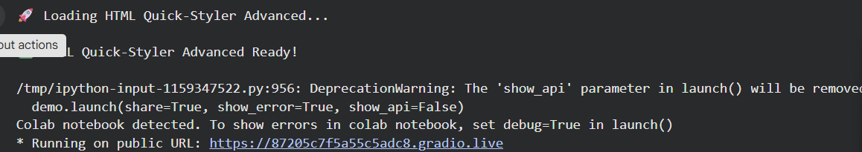

- Generated Gradio Public URL
Public URL: :https://87205c7f5a55c5adc8.gradio.live
This screenshot shows the public URL generated by Gradio which allows users to access the application through a web browser.
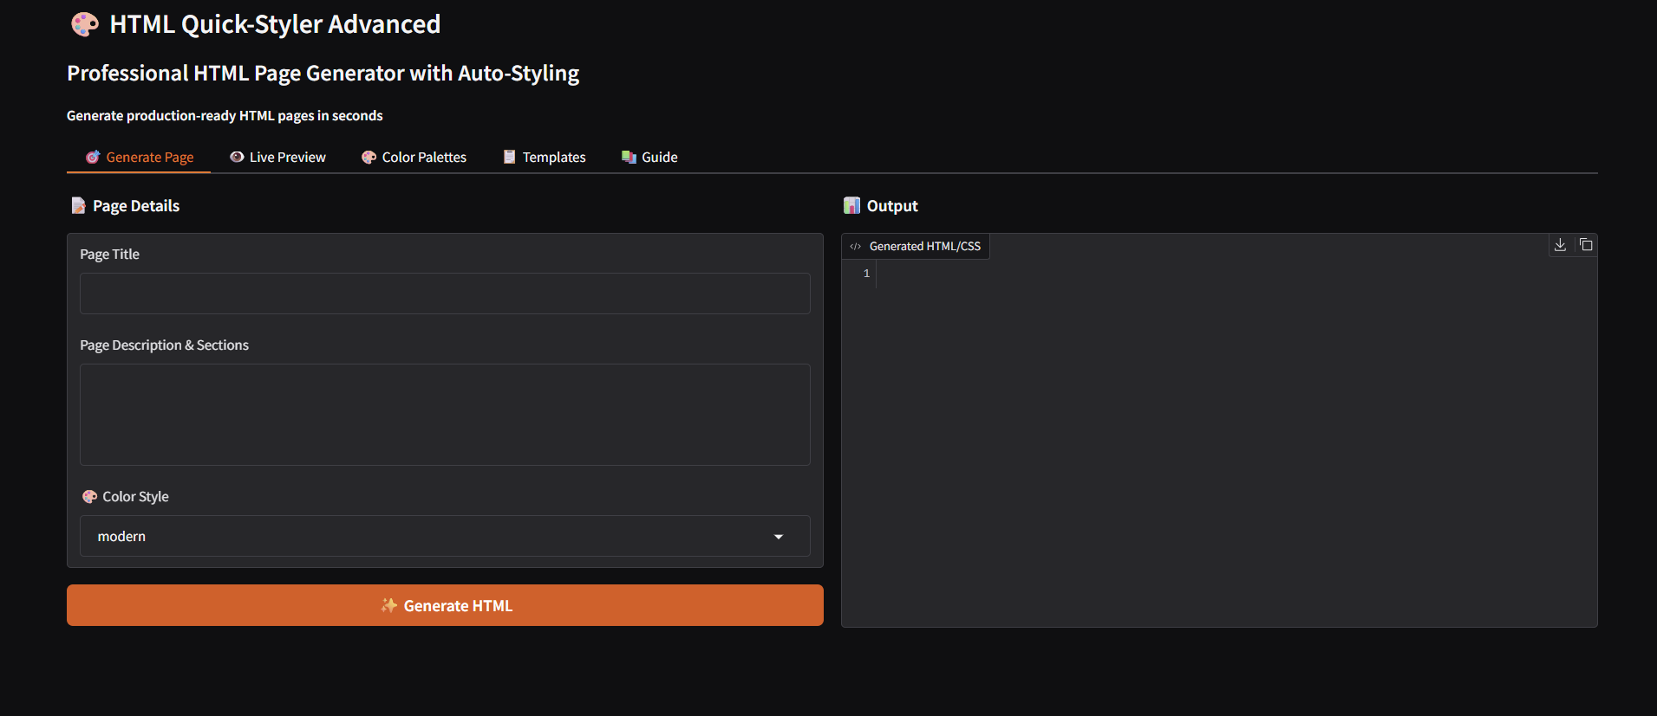

- Website Generation Input Interface

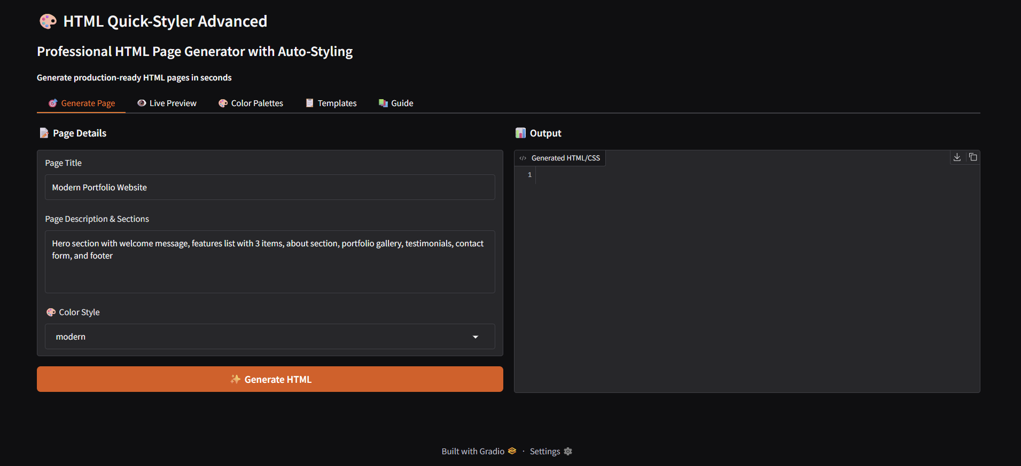

- Generated Website Output

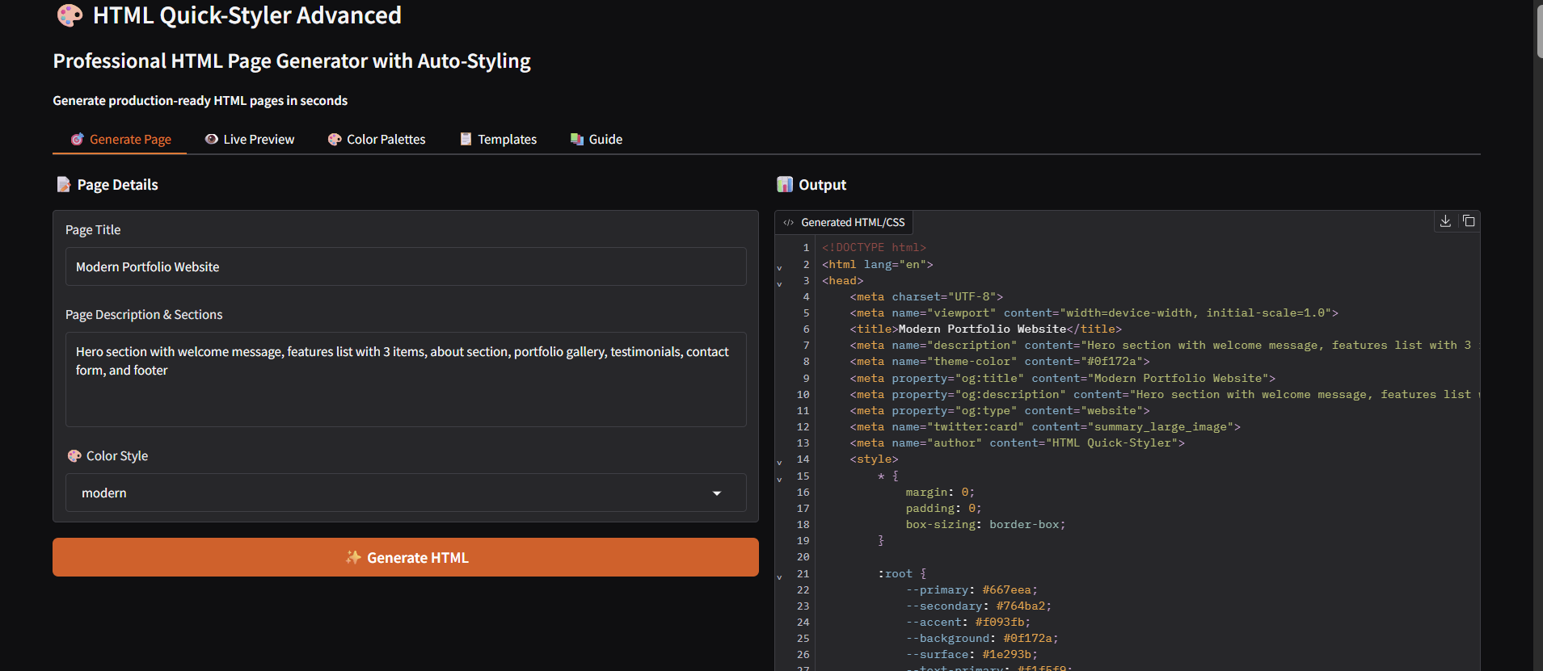

- Final Generated Website
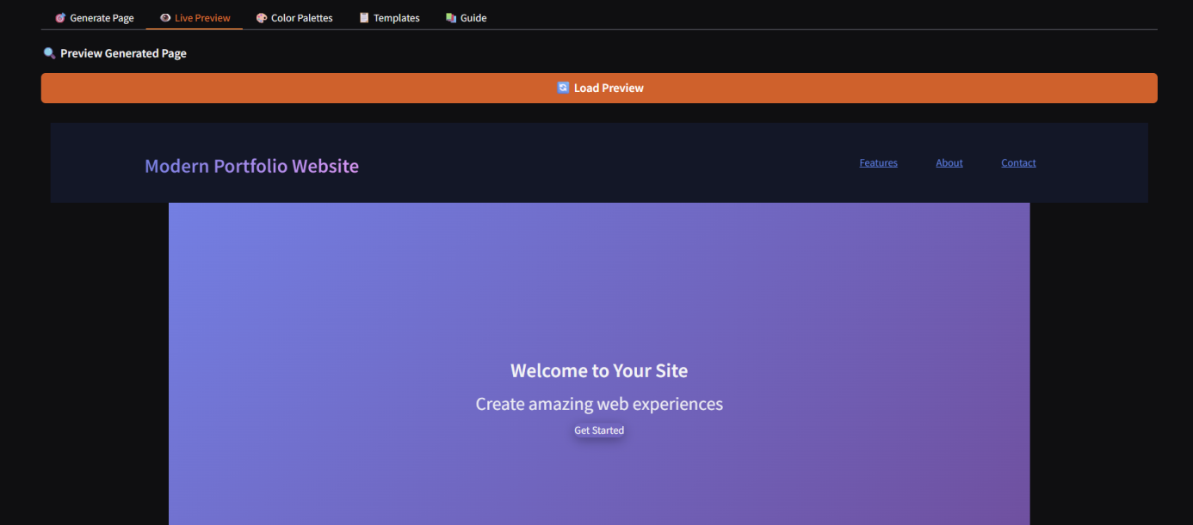

- Color Palette Selection
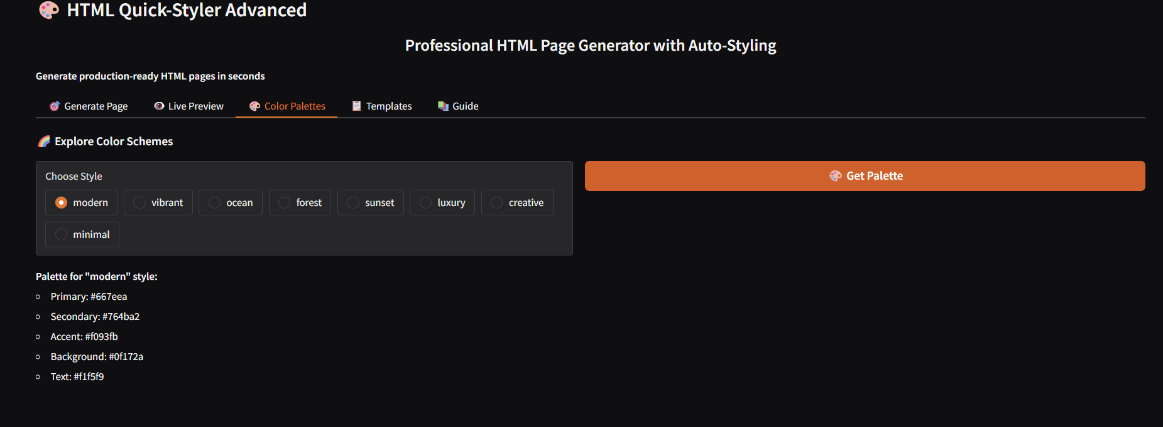

- Templates
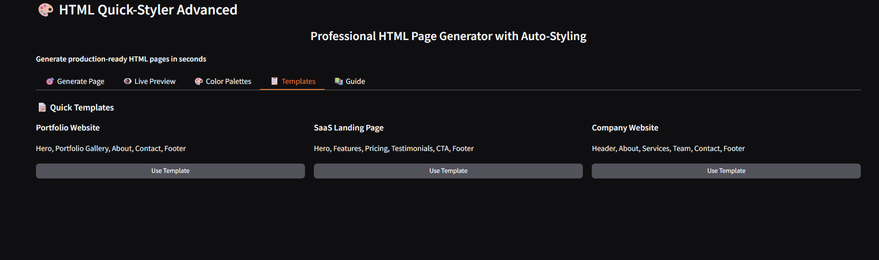

CONCLUSION

8. CONCLUSION

HTML Quick-Styler effectively functions as an intelligent web page generation tool that integrates user-friendly design templates with the capabilities of the IBM Granite 3.3 2B Instruct model. By utilizing the Gradio interface framework along with Google Colab’s cloud-based environment, the platform enables quick, professional, and customizable HTML and CSS generation. This makes the system accessible not only to web developers and designers but also to users with little or no technical background.
The platform proves that AI-assisted web development can simplify the process of building professional websites while still maintaining high standards of design, responsive layouts, and production-ready code. With features such as eight unique color palettes, smart section identification, and a wide range of templates, HTML Quick-Styler allows users to design visually appealing websites within minutes instead of spending hours on manual development.
In the future, the platform can be enhanced by adding features such as a custom color picker, automatic JavaScript functionality generation, an expanded component library, and integration with popular web development frameworks. Because the system follows a modular architecture, it can be easily extended and modified to support new design trends and changing user requirements.

